

**Table of Contents**

1. **Introduction**
2. **Problem Statement**
3. **Objectives of the Study**
4. **Data Collection**
   1. **Dataset Description**
   2. **Data Source**
5. **Data Cleaning**
   1. **Handling Missing Values**
   2. **Data Type Corrections**
   3. **Removing Invalid Records**
6. **Data Preprocessing**
   1. **Feature Engineering**
   2. **Profit and ROI Calculation**
   3. **Data Categorization**
7. **Exploratory Data Analysis (EDA)**
   1. **Overall Movie Performance**
   2. **Genre Distribution**
   3. **Budget vs Revenue Analysis**
8. **Genre-Wise Analysis**
   1. **Action Genre**
   2. **Adventure Genre**
   3. **Comedy Genre**
   4. **Drama Genre**
   5. **Animation Genre**
9. **Director-Wise Analysis**
   1. **Experienced Directors Analysis**
   2. **Budget-Friendly Directors**
   3. **Big Budget and Big Profit Directors**
10. **Key Insights and Findings**
11. **Conclusion**
12. **Limitations of the Study**
13. **Future Scope**
14. **References**

**Introduction**

The movie industry involves high investment and significant financial risk. This project aims to analyse movie data to understand what factors contribute most to movie success and profitability. Using real-world movie data from TMDB, this analysis explores relationships between budget, revenue, profit, return on investment (ROI), genre popularity, and director experience.

The dataset consists of thousands of movies across multiple genres and languages. After cleaning and preprocessing the data, exploratory data analysis (EDA) and visualization techniques were applied using Python and Power BI.

Key findings show that 76% of movies belong to five major genres, and Animation and Comedy genres provide the highest ROI with lower budgets, while Action and Adventure genres require experienced directors to remain profitable. The project provides data-driven recommendations to support better investment and production decisions in the film industry.

**Problem Statement**

To identify the key factors influencing movie success and profitability in order to support data-driven movie production and investment decisions.

**Objectives**

* Analyse movie budget, revenue, profit, and ROI
* Identify the most profitable genres
* Study director experience (6–10 movies) and consistency
* Compare low-budget vs high-budget movie performance
* Provide actionable business insights using visualization

**Data collection**

* Data Source
* The dataset used in this project is the TMDB 5000 Movies Dataset, obtained from Kaggle.
* Files Used

tmdb_5000_credits.csv

tmdb_5000_movies.csv

<https://www.kaggle.com/datasets/tmdb/tmdb-movie-metadata>

* Key Attributes
* Budget
* Revenue
* Genres
* Directors
* Language
* Popularity
* Why TMDB?
* TMDB provides structured and real-world movie financial data, making it suitable for profitability and performance analysis.

**Data View**

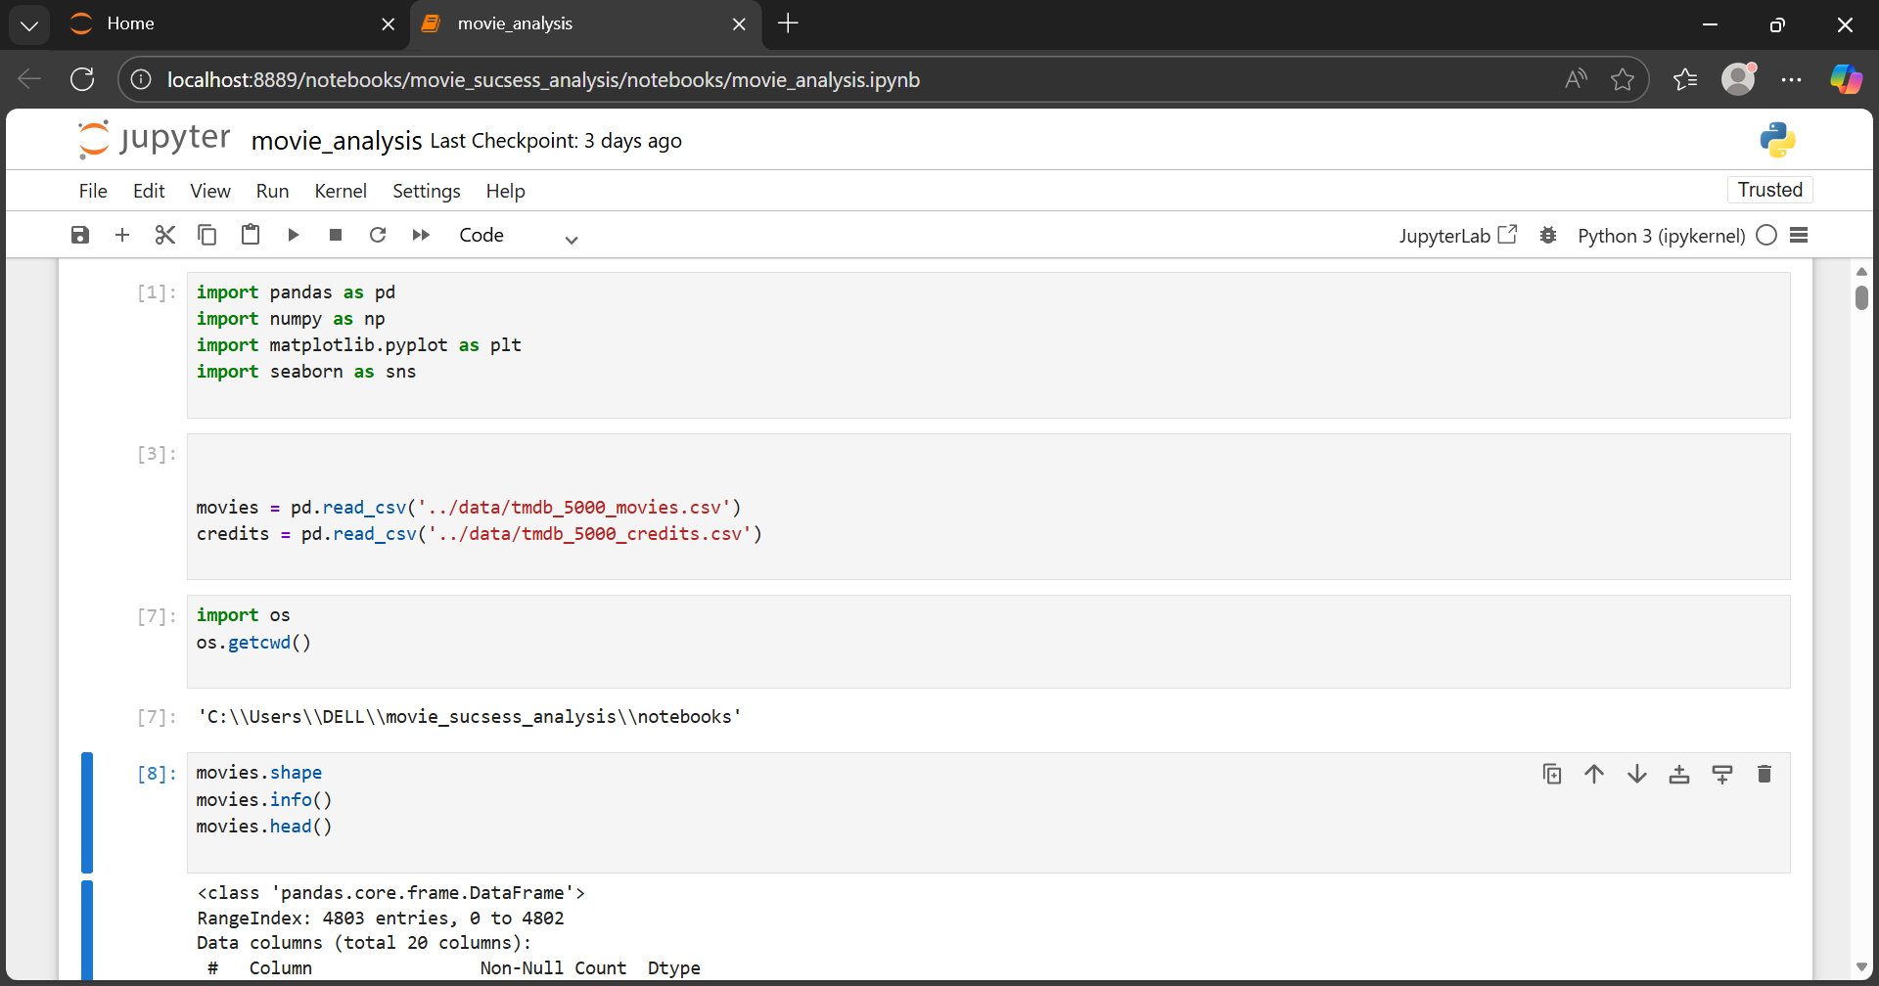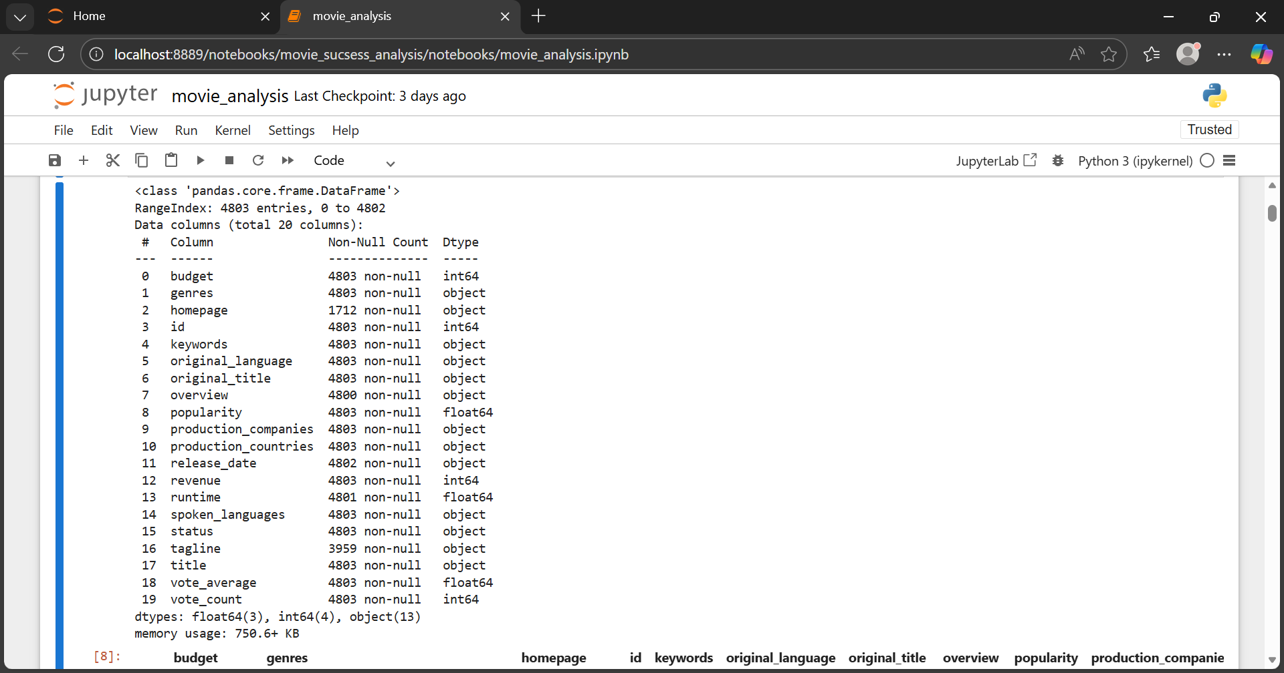

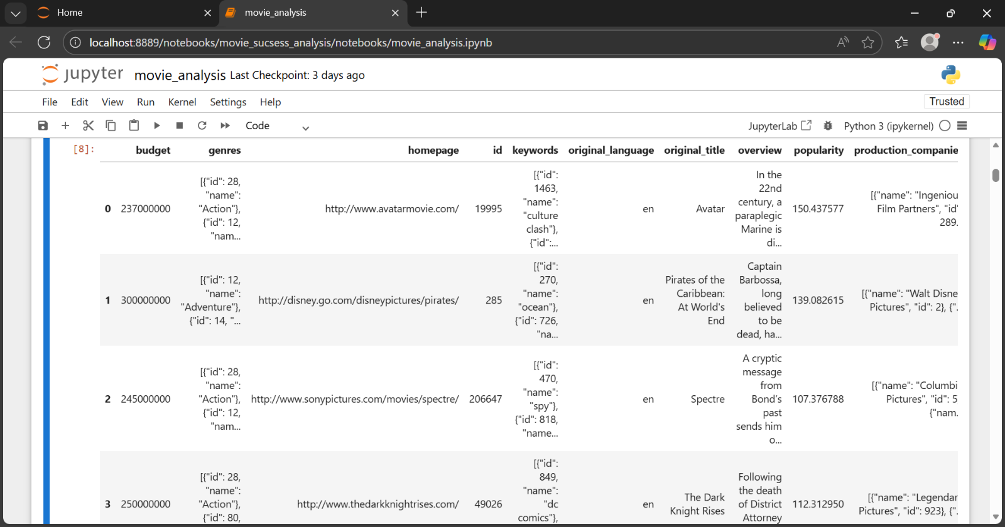

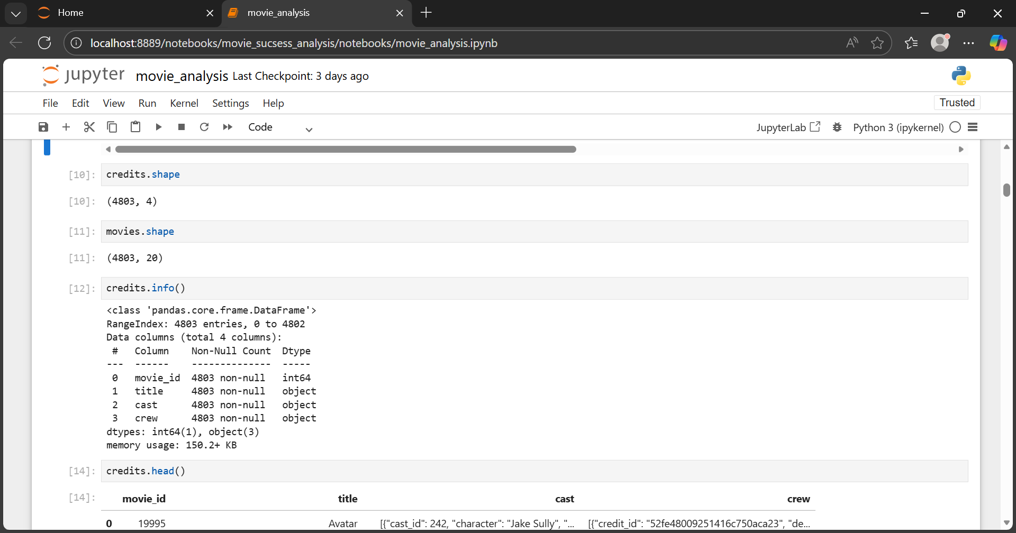

**Data Cleaning**

Raw datasets often contain missing, incorrect, or inconsistent values. To ensure accurate analysis, several data cleaning steps were performed.

Cleaning Steps

* Removed movies with 0 budget or 0 revenue
* Removed rows with missing release dates
* Handled missing text fields
* Standardized column formats
* Removed duplicate records

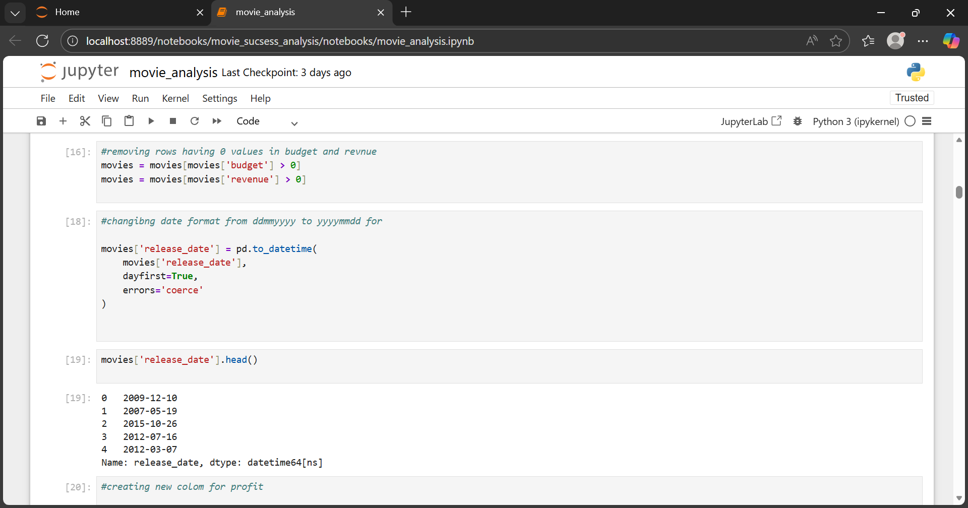

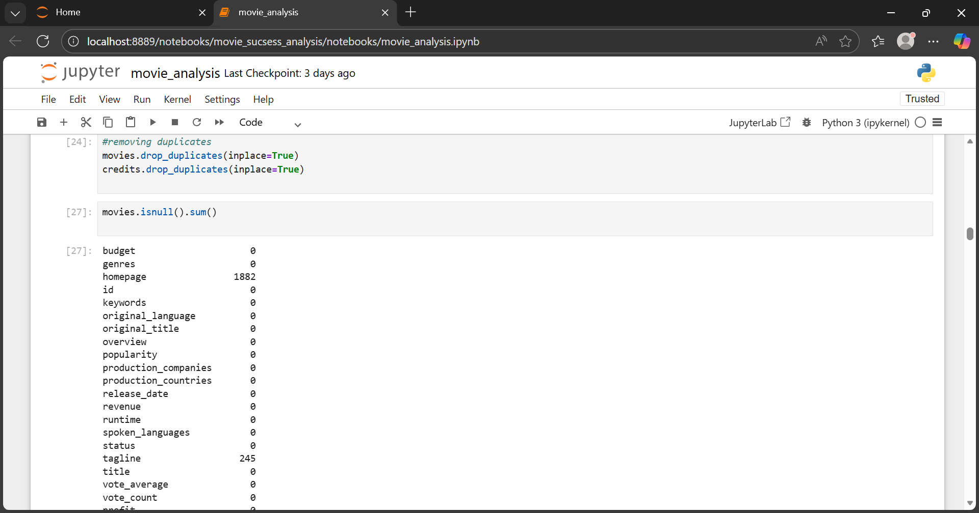

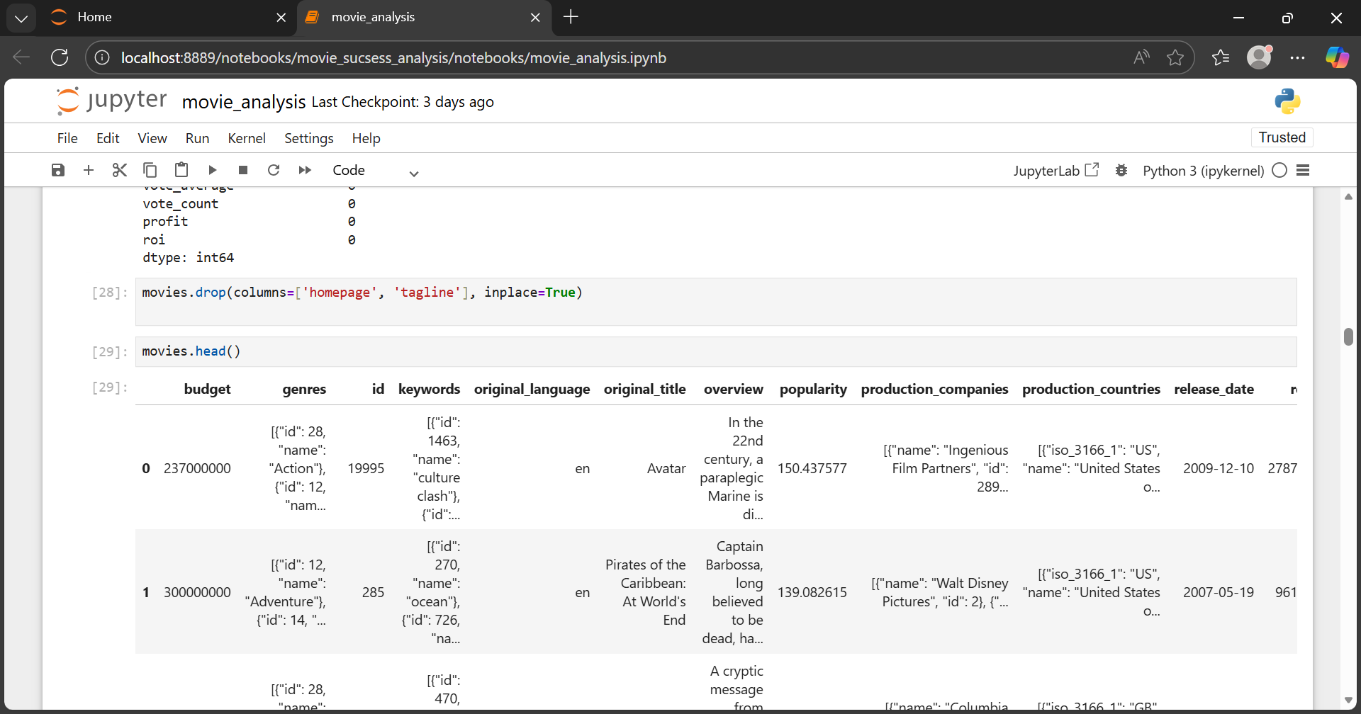

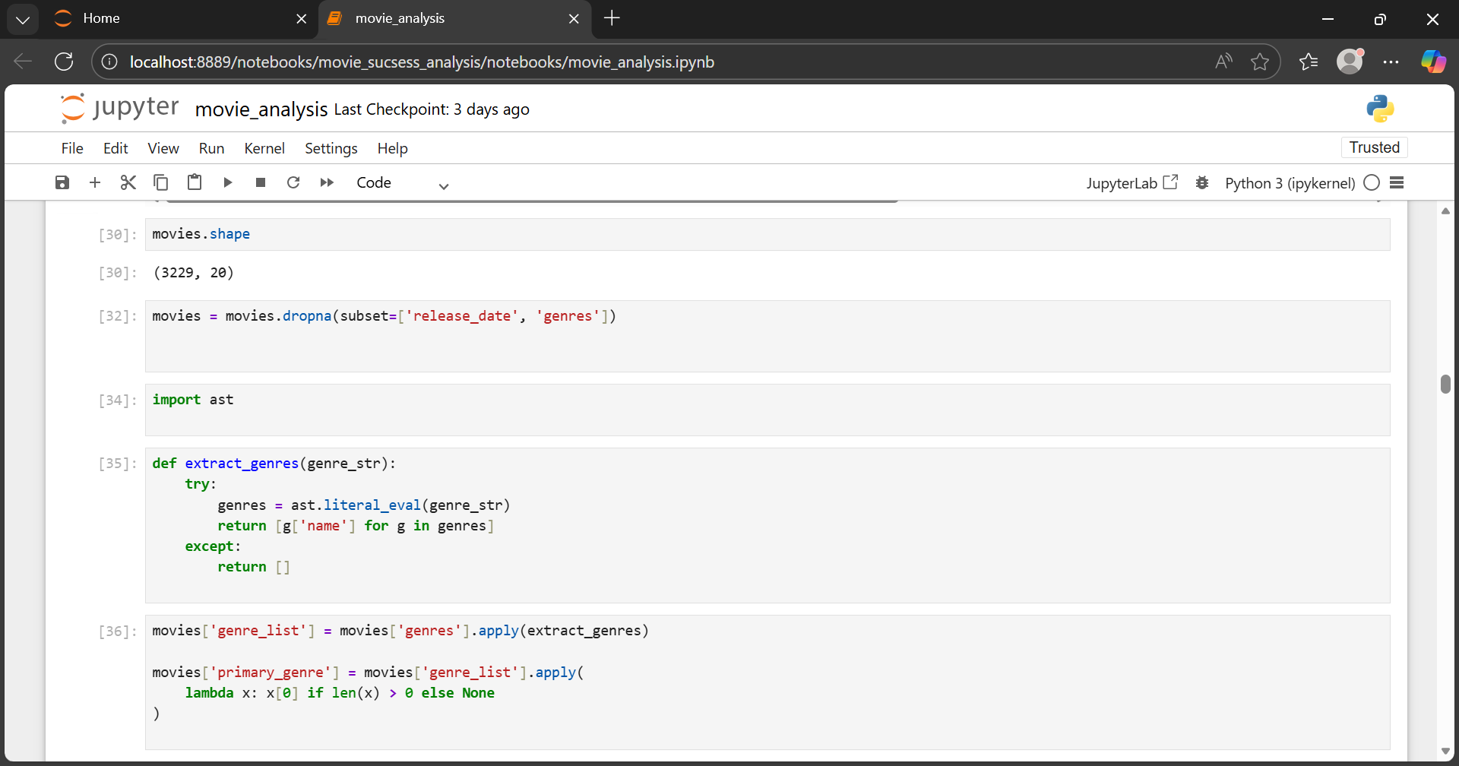

* Importance
* Cleaning ensures that ROI and profit calculations are not misleading or inflated

**Data Preprocessing**

* After cleaning, data preprocessing was applied to prepare the dataset for analysis.
* Merged movie and credit datasets

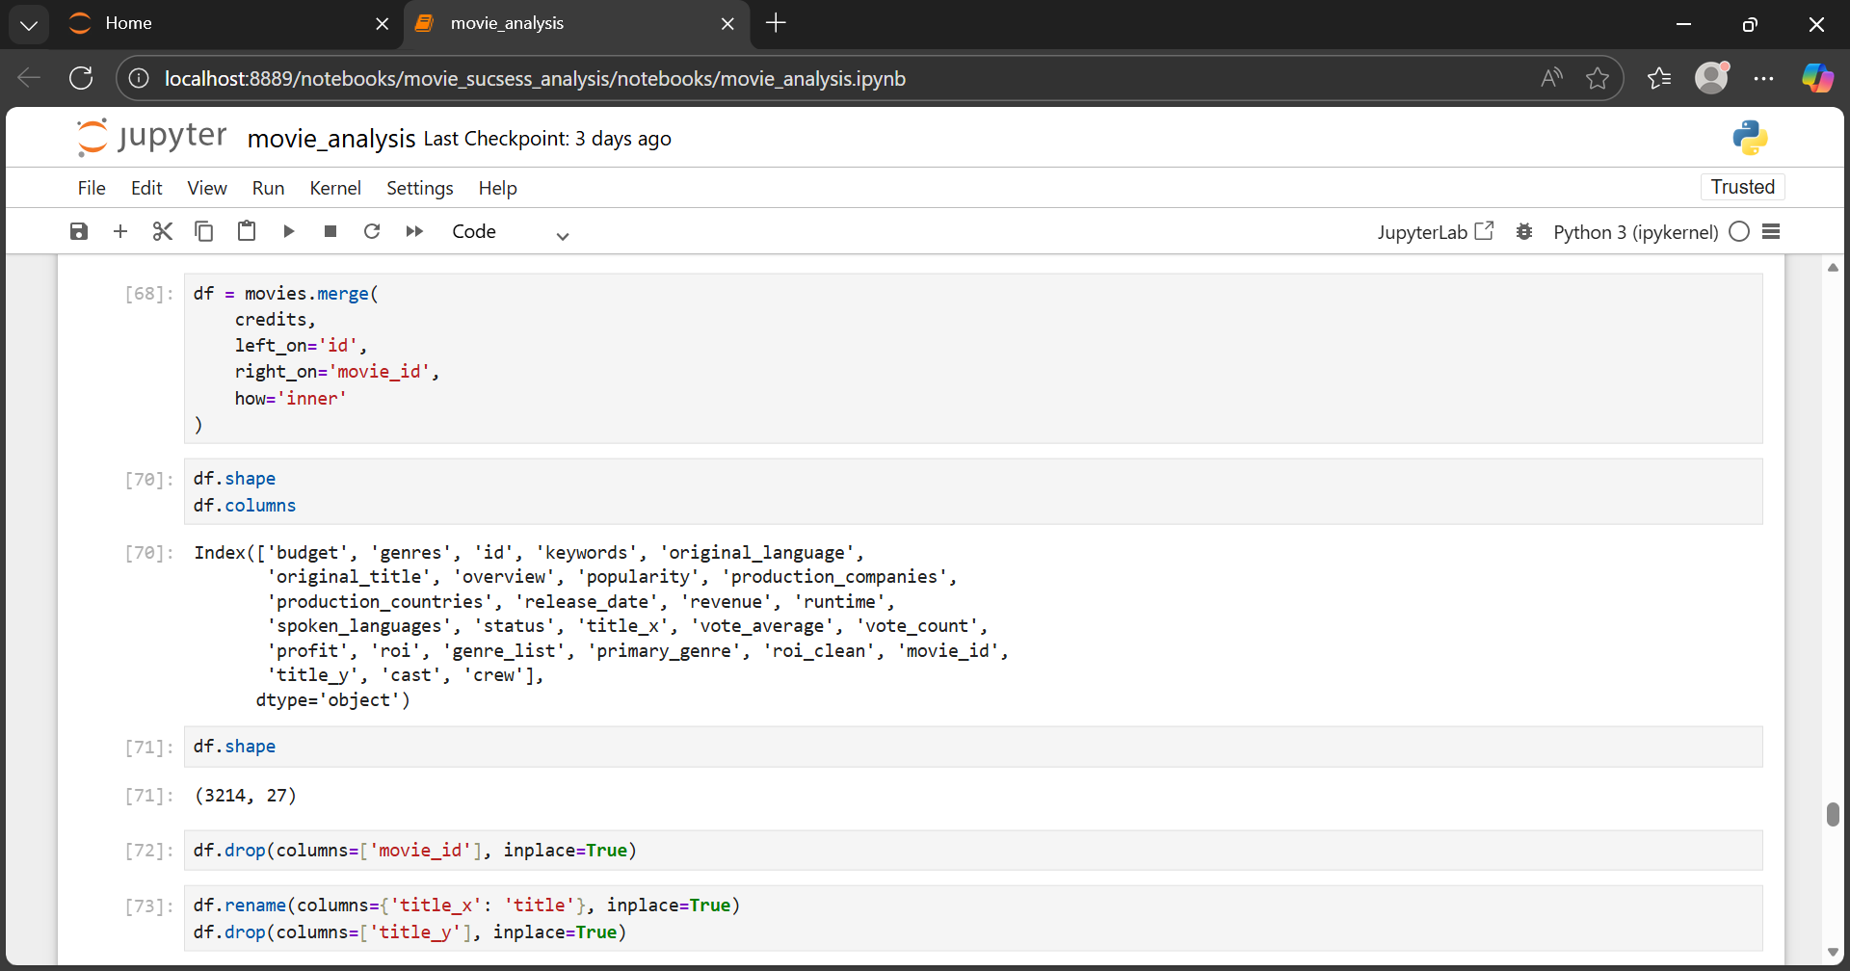

* 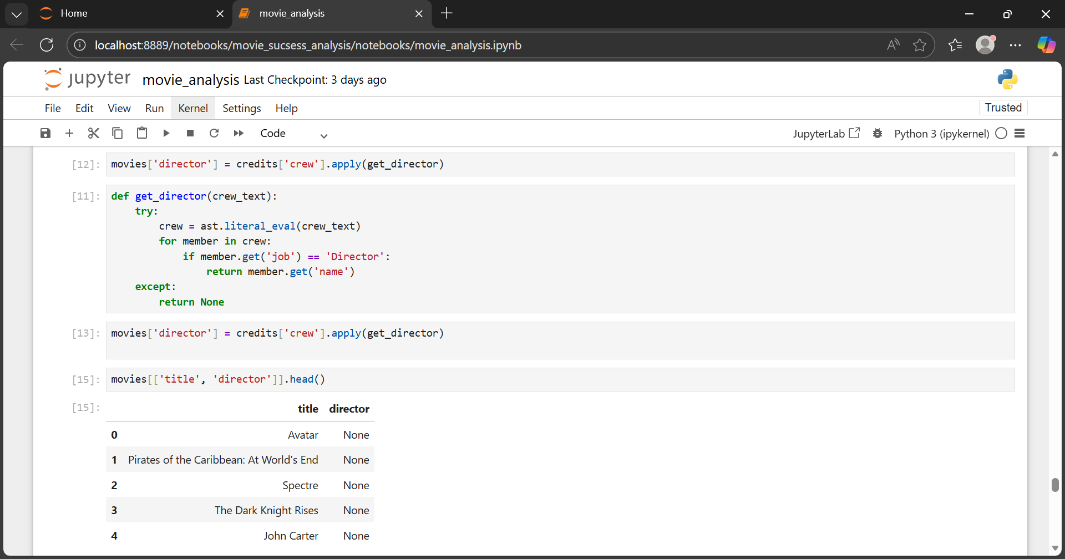Extracted director names from nested JSON
* Converted release dates to year format

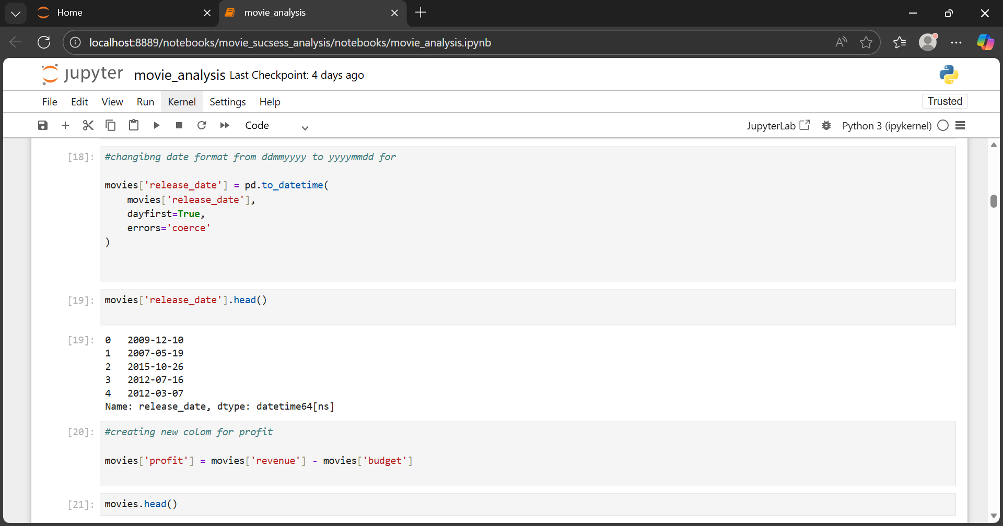

* New Columns Created
* Profit = Revenue – Budget

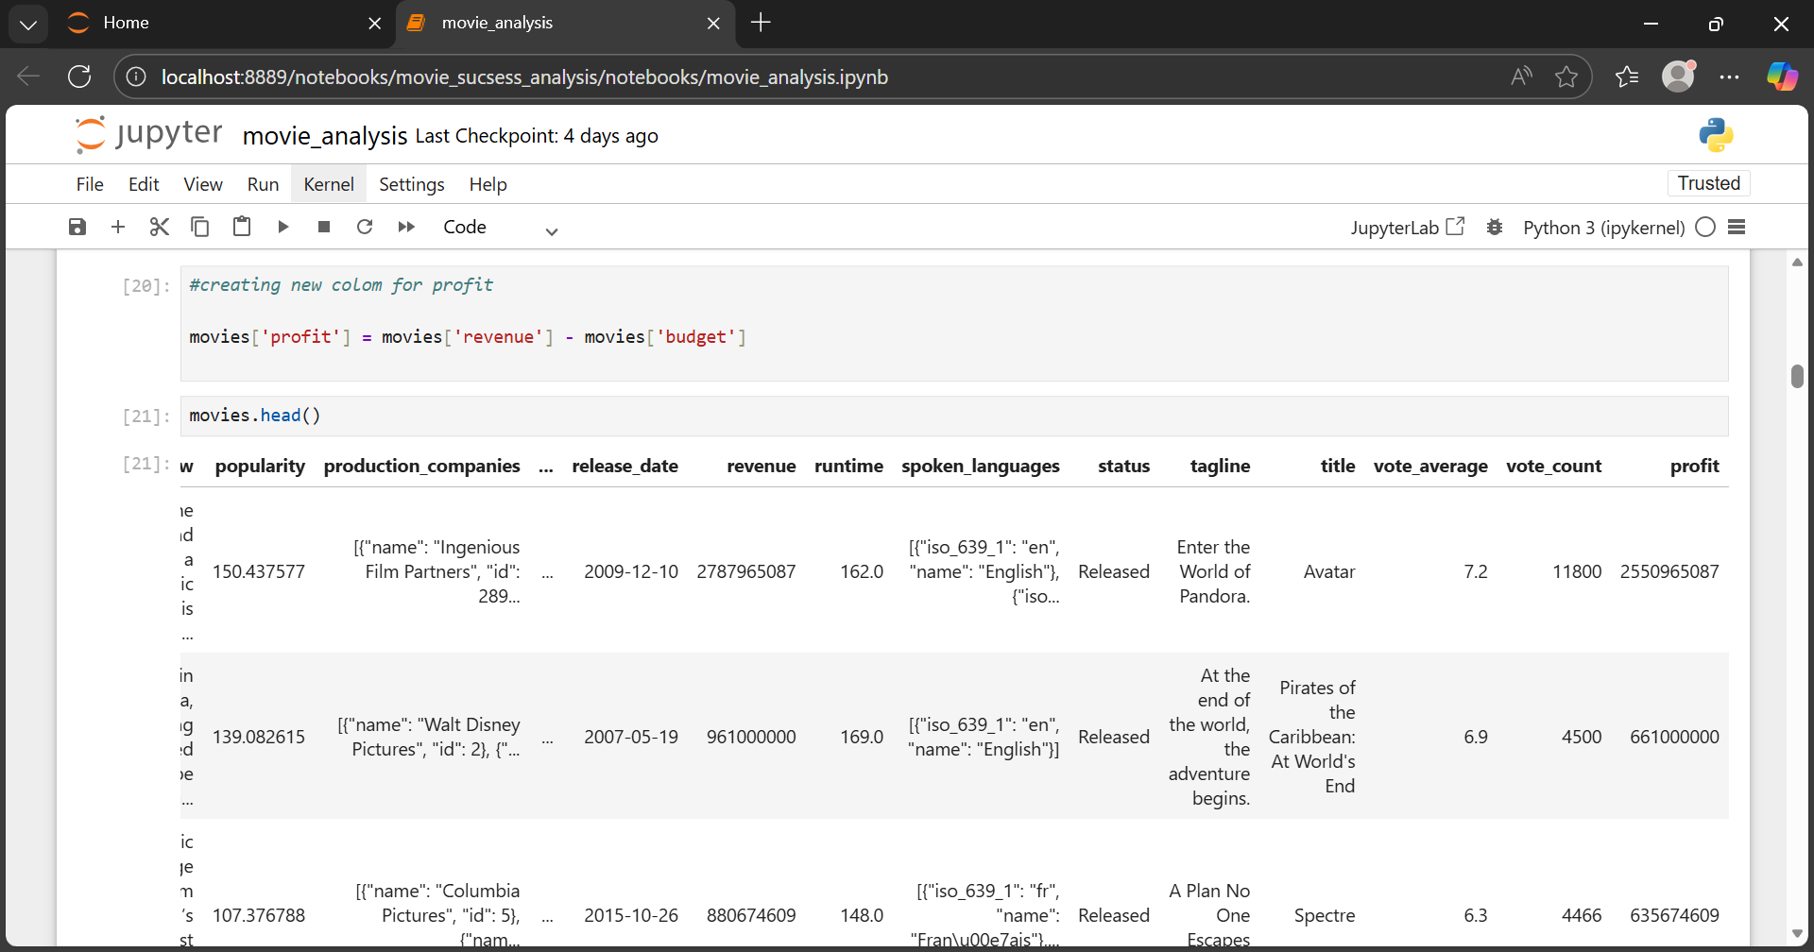

* ROI = Profit / Budget

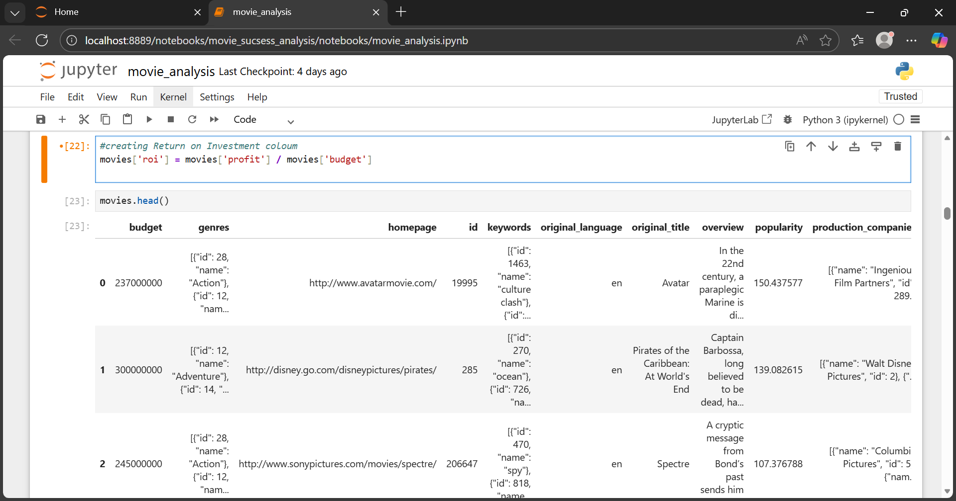

* Primary Genre

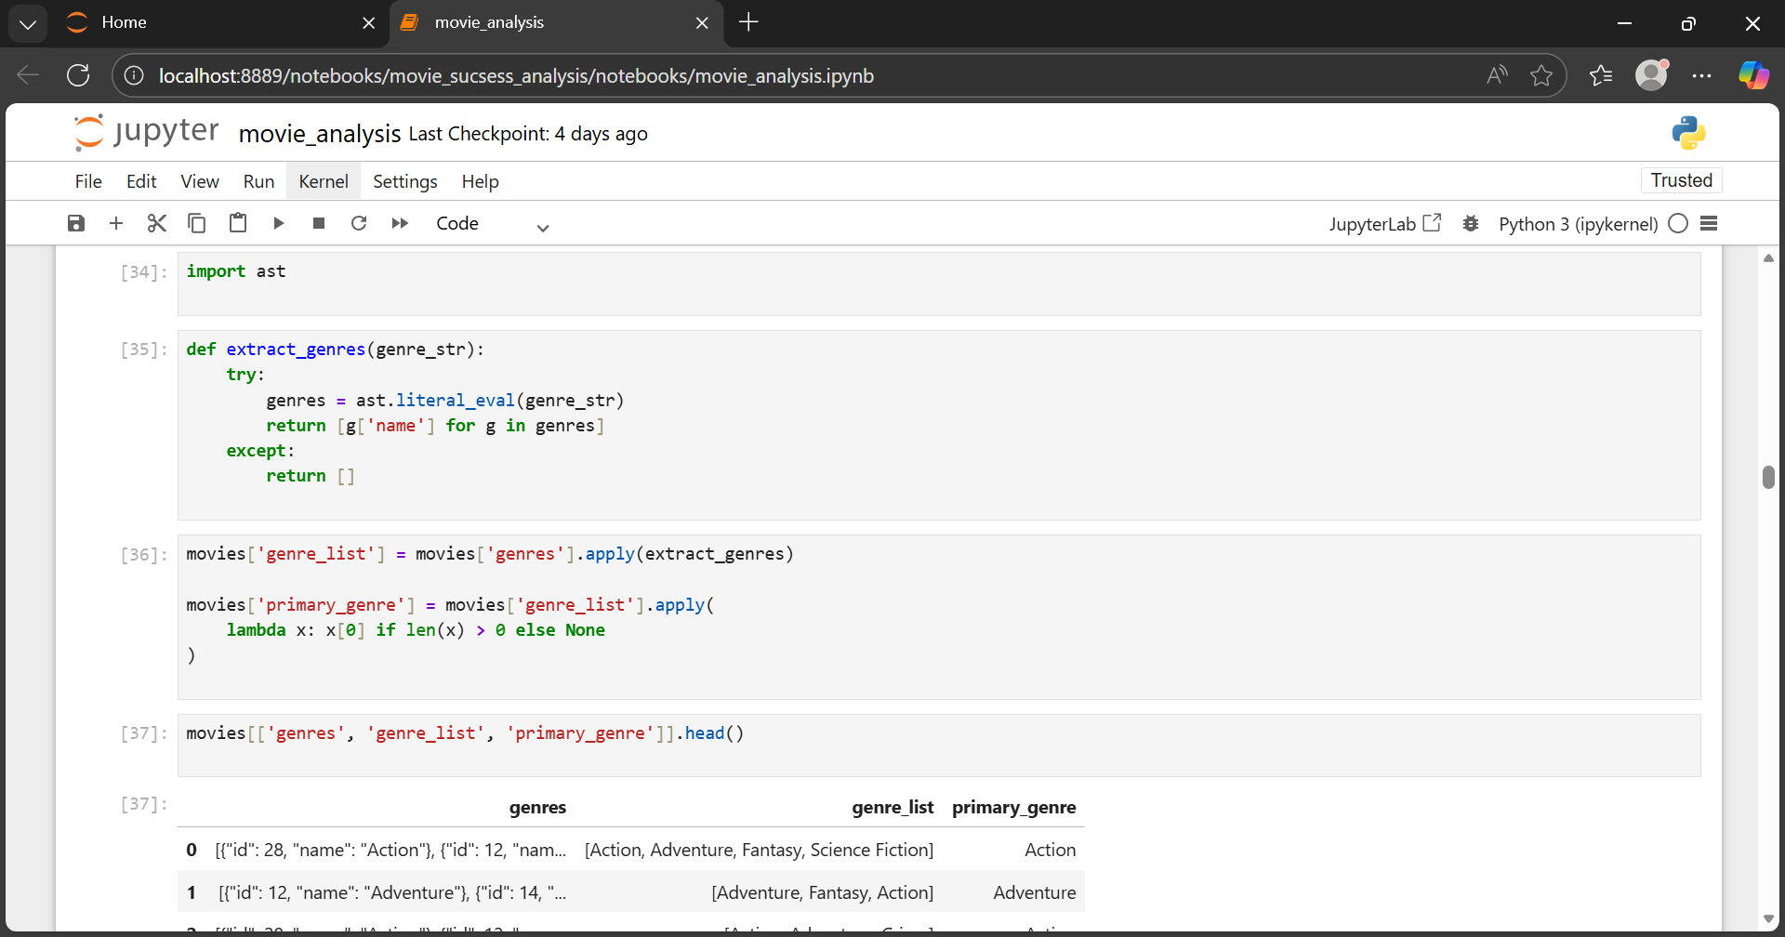

* Movie Verdict (Flop, Average, Hit, Blockbuster)

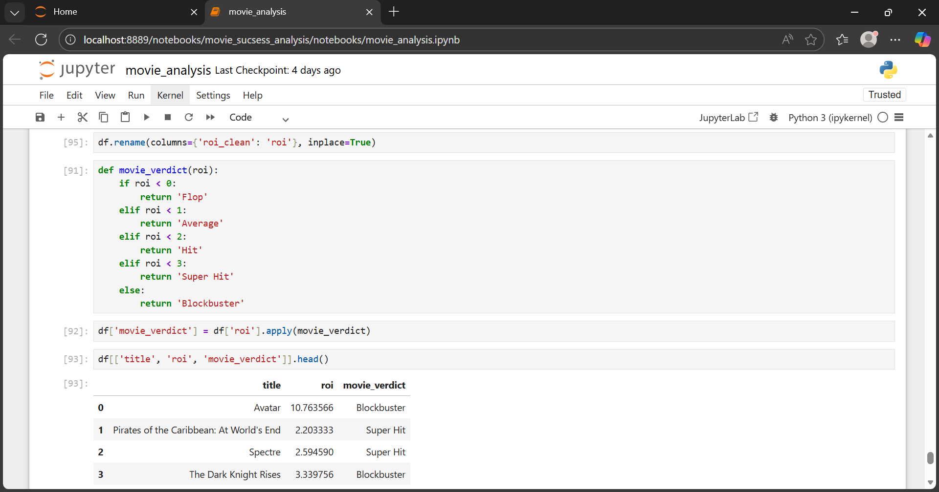

**Exploratory Data Analysis**

* EDA helps uncover hidden patterns and trends in the data.

1. Does higher budget guarantee success?

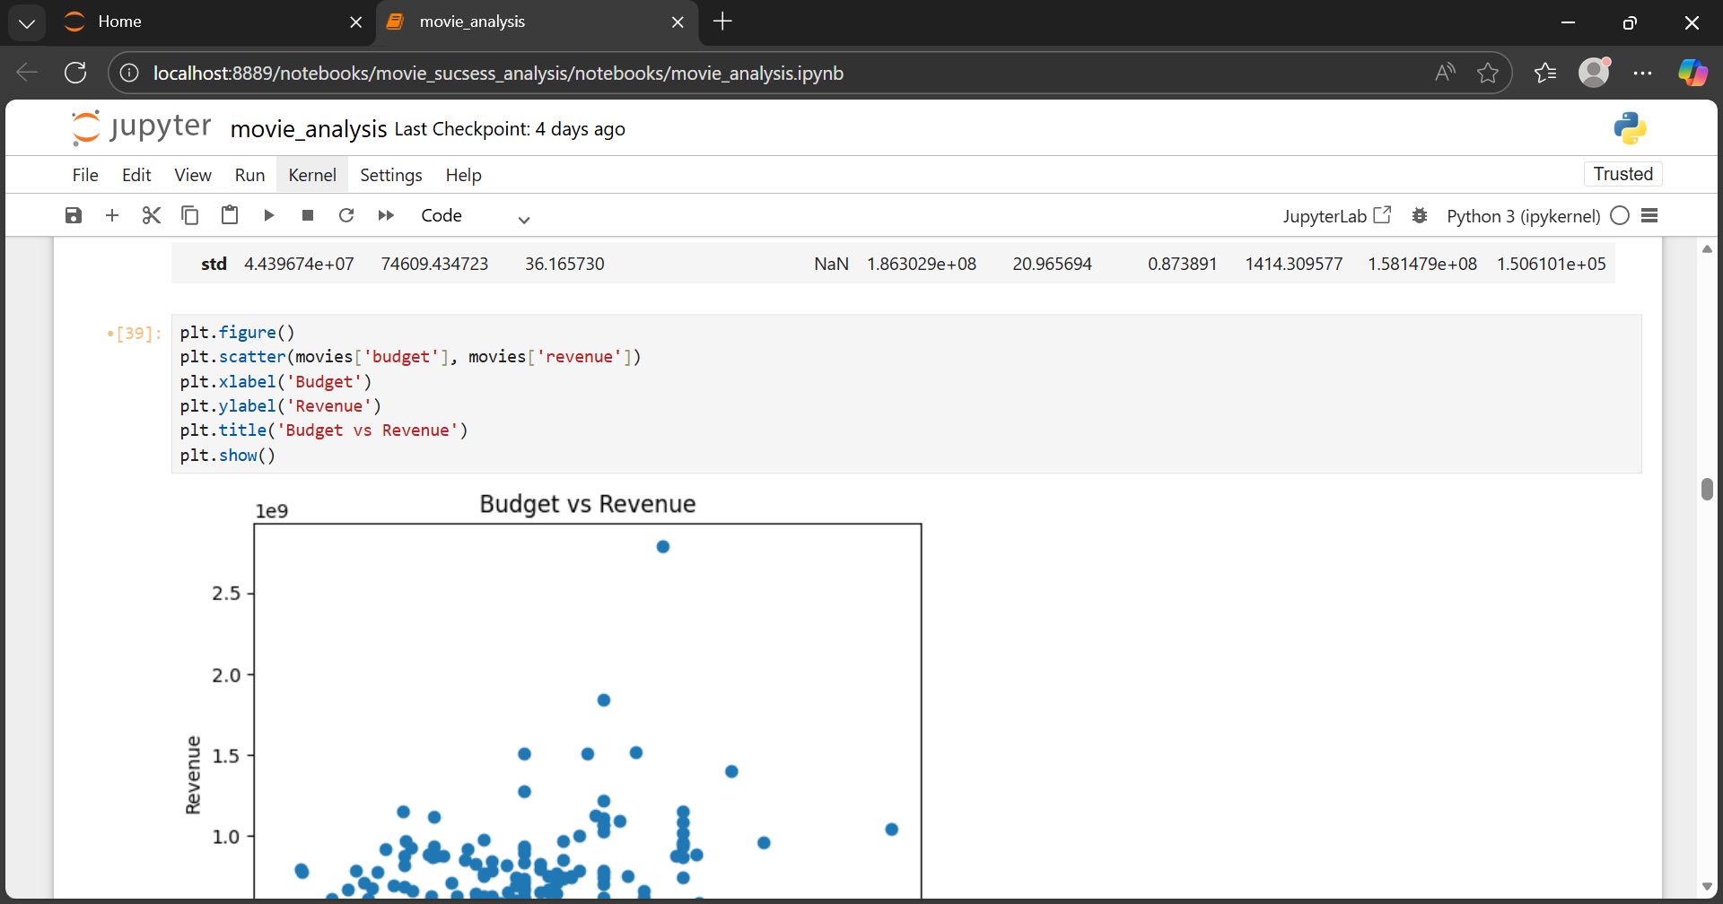

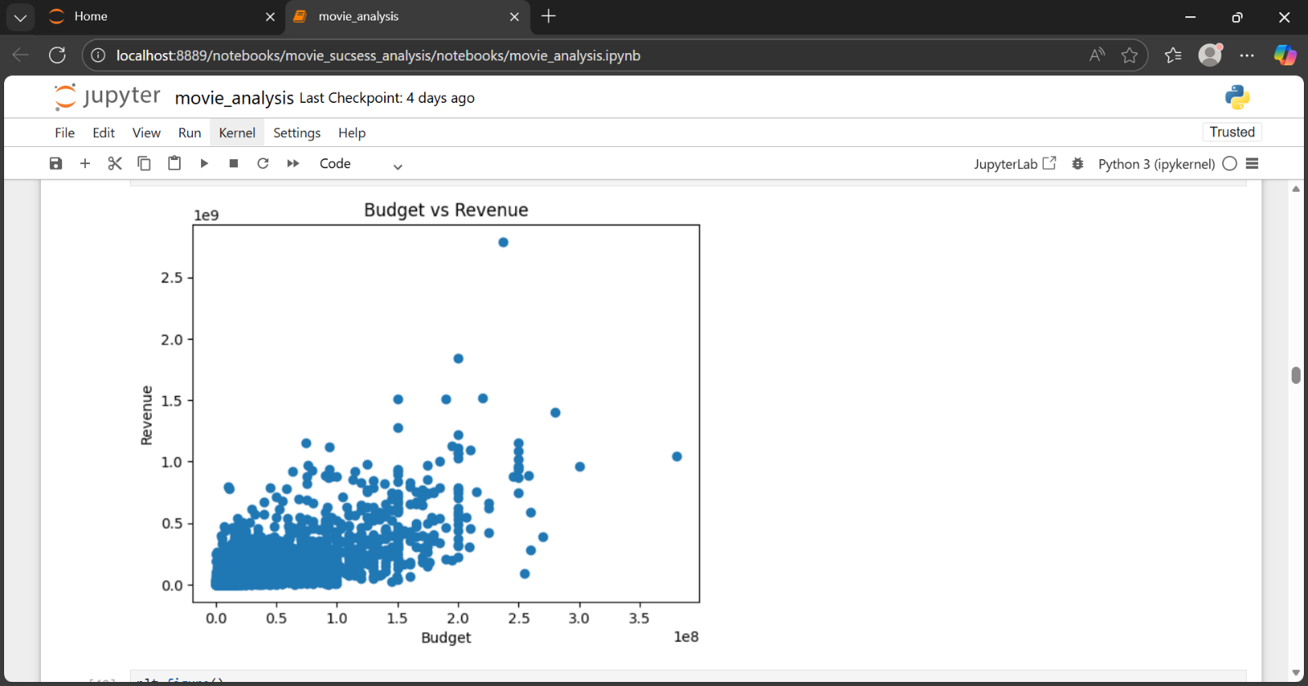

* Budget alone does not guarantee success

**2**.Which genres dominate the industry?

* In terms of quantity

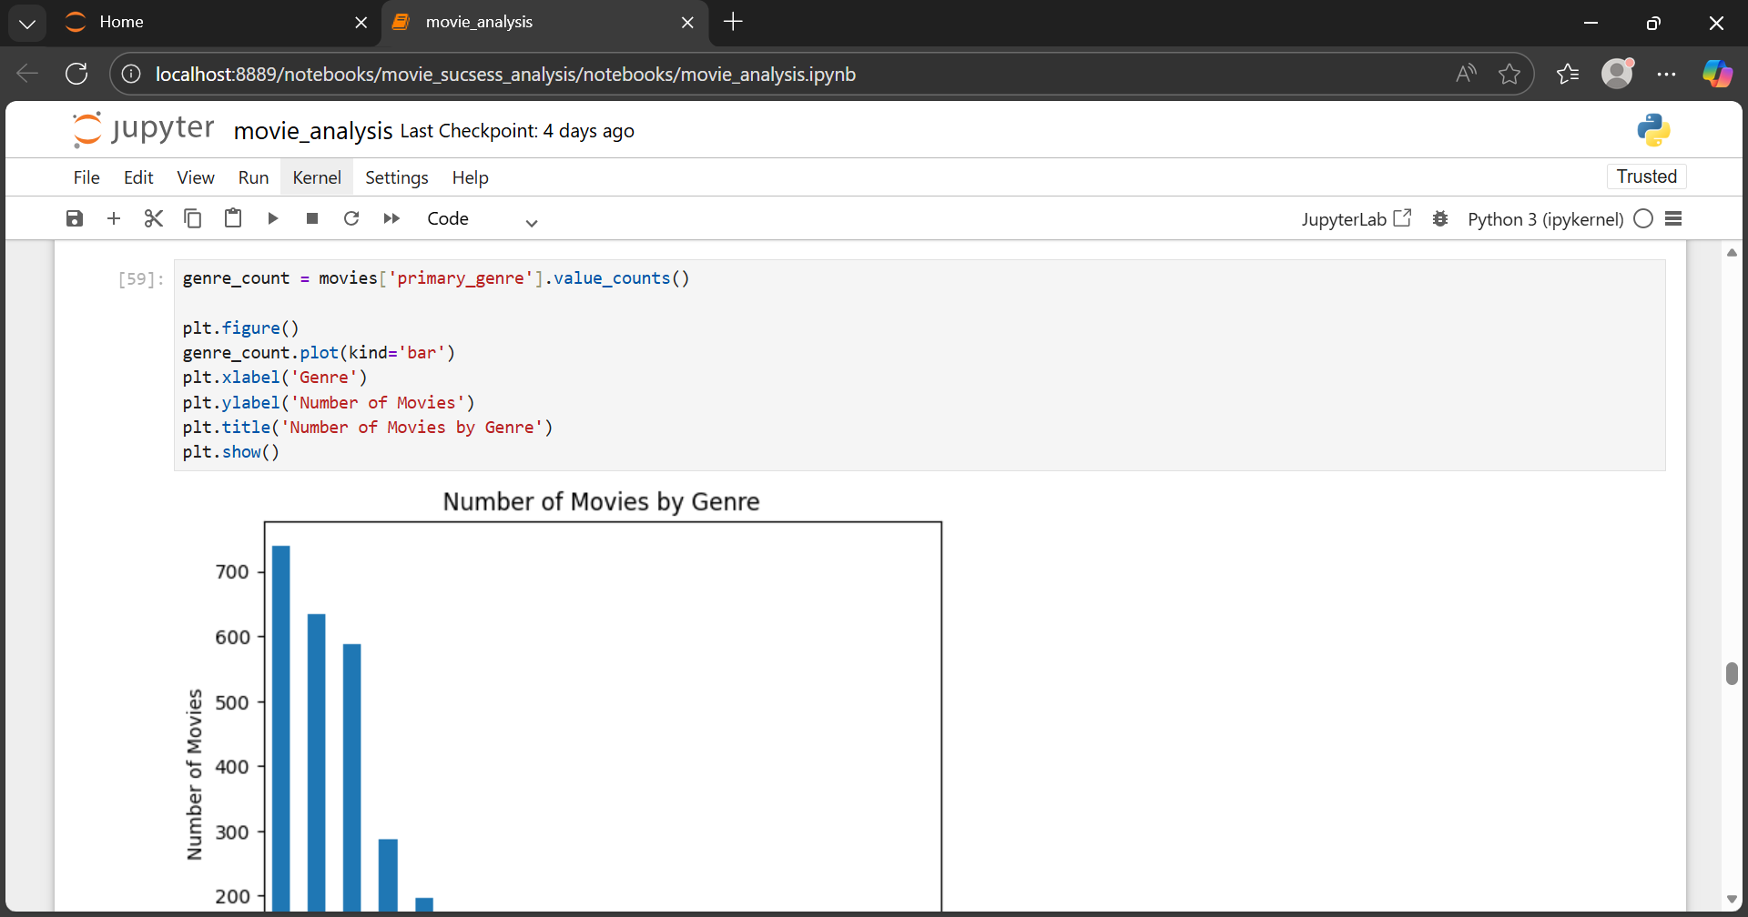

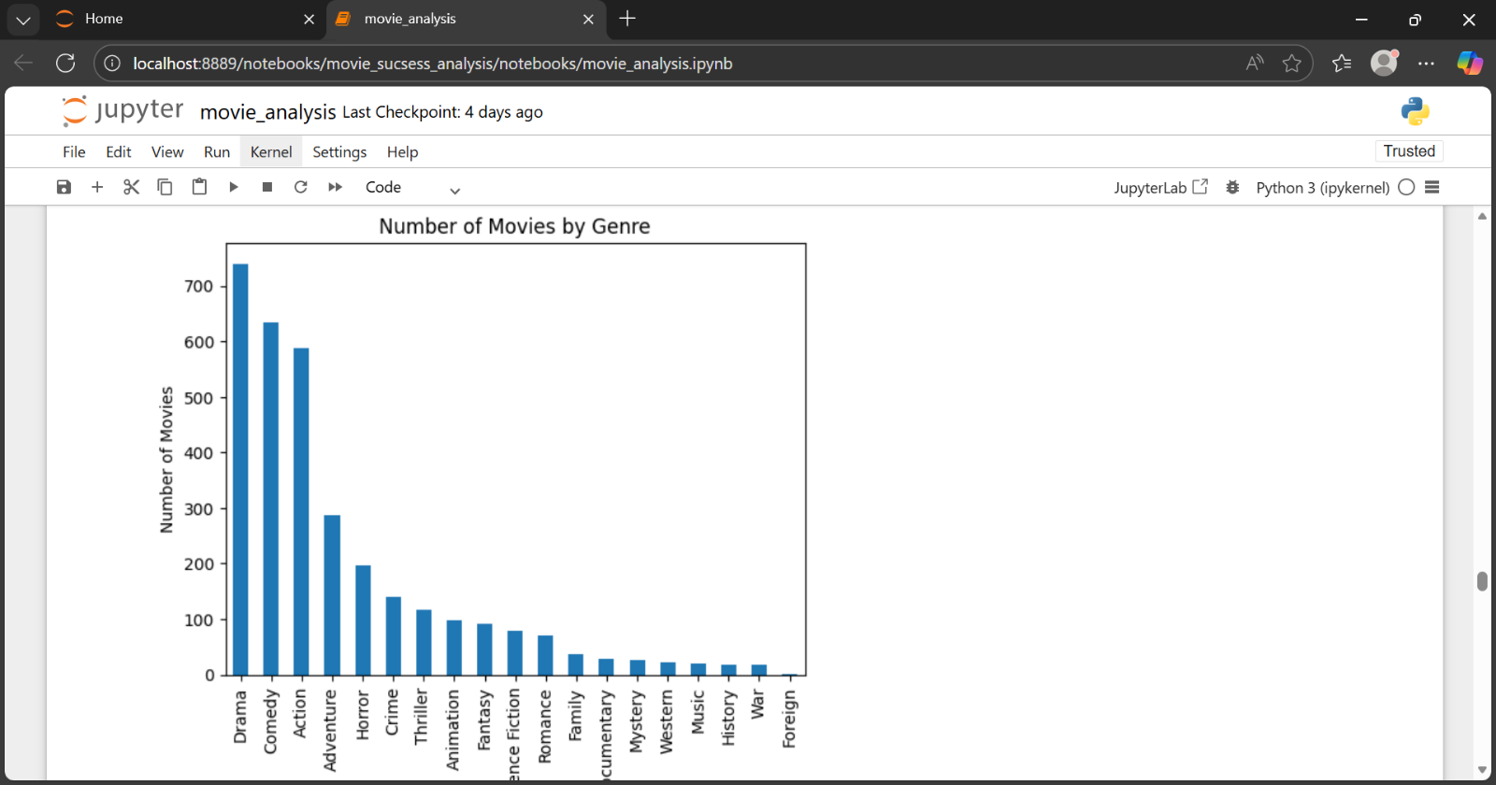

* In terms of quantitiy Drama ,Comedy and Action genre dominates.
* Drama genre is on top.
* In terms of Average Profit

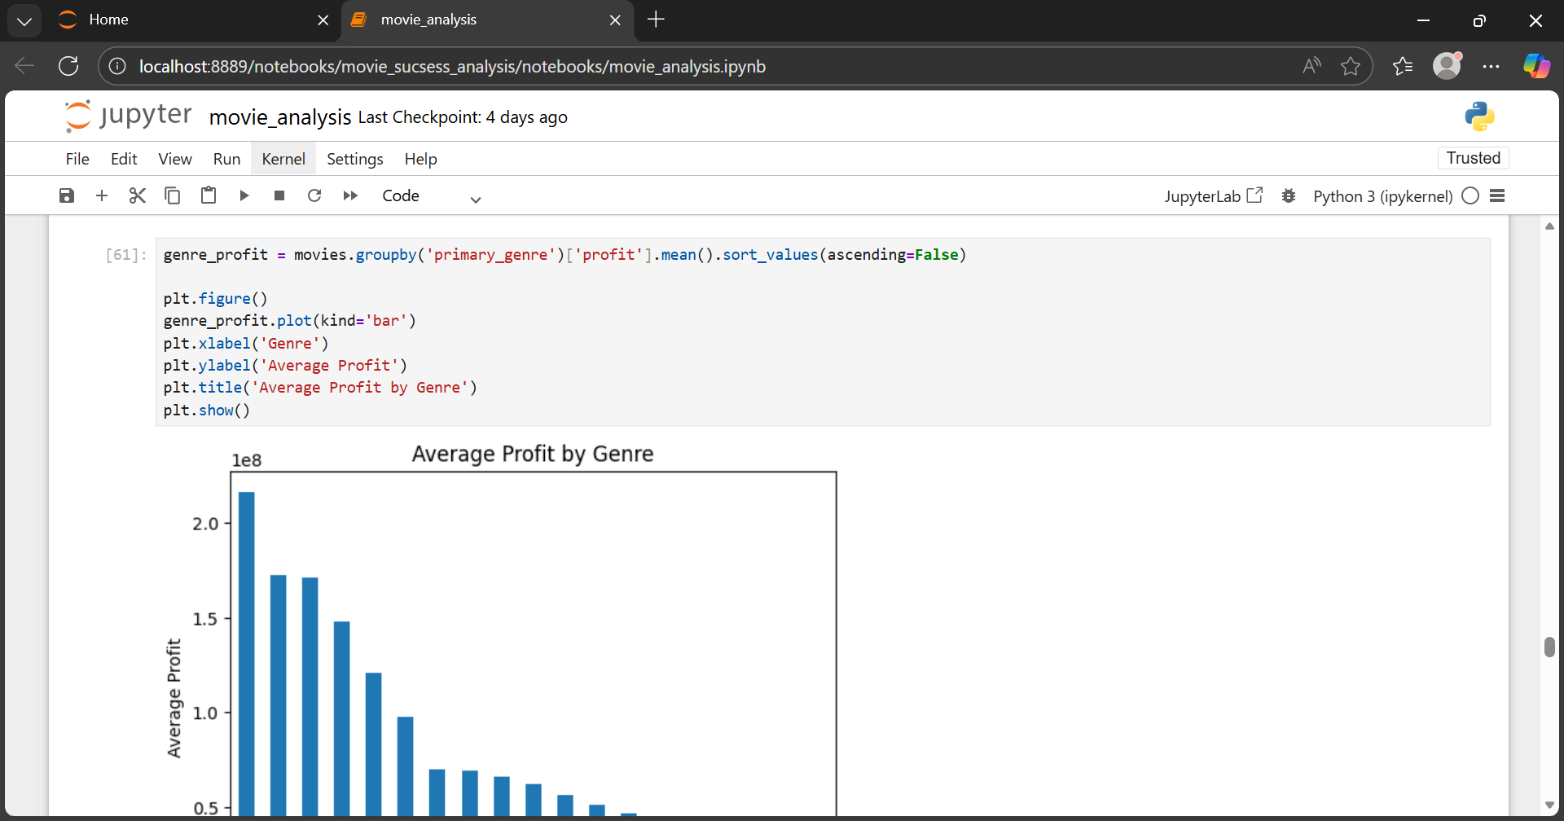

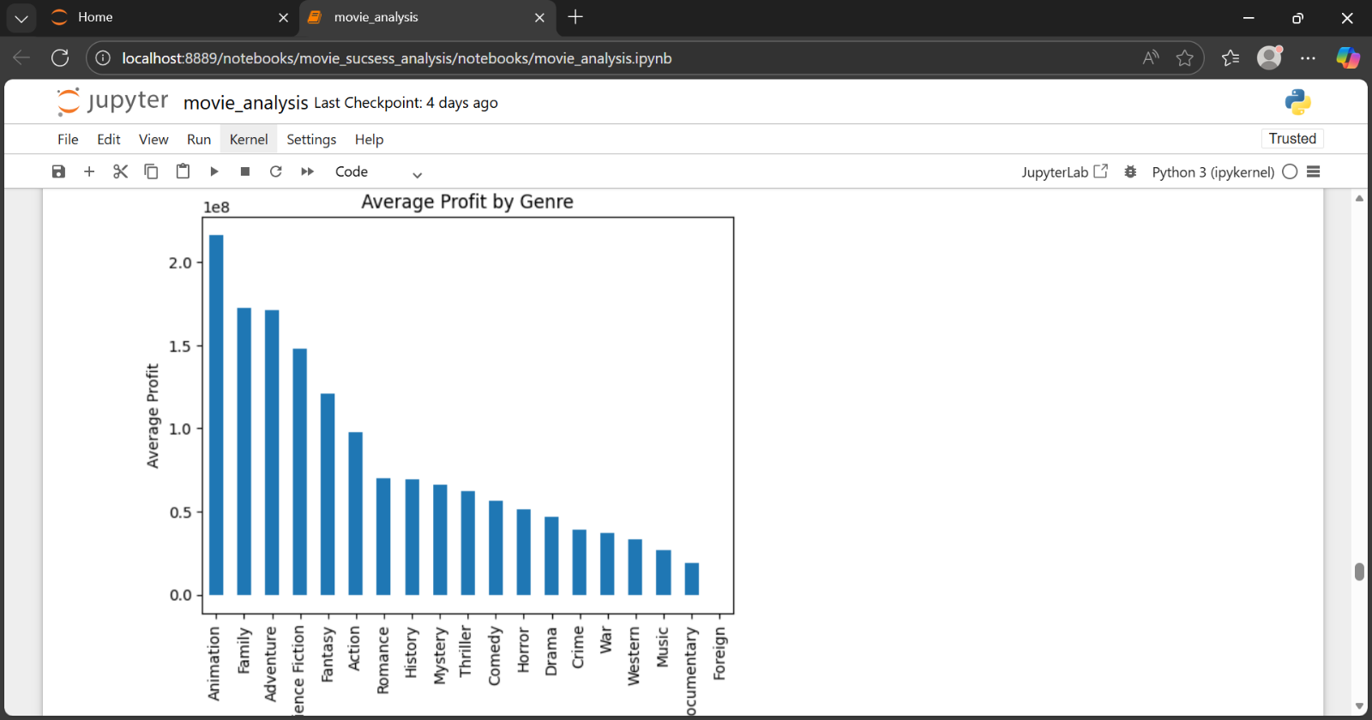

* Average Profit in Animation dominates.
* In terms of sum of Profit

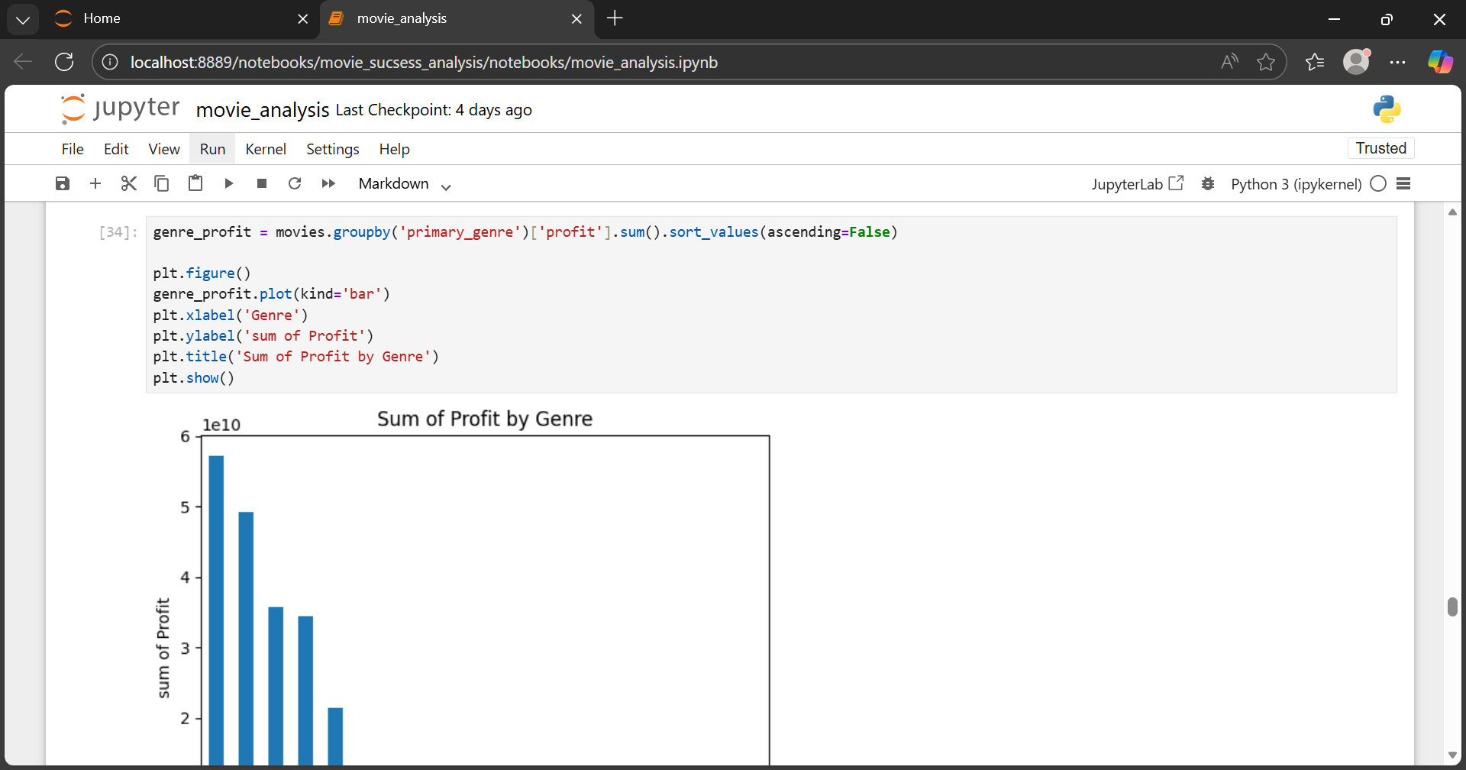

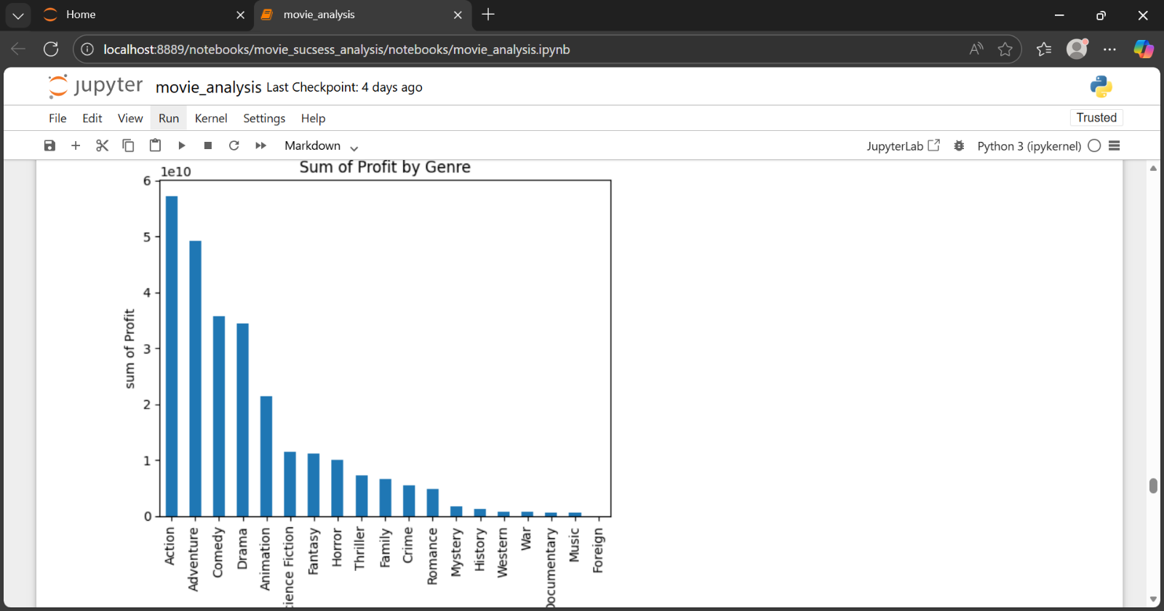

* Action Genre wins

**Data Visualization in Power BI**

* Final Dashboard
* Dashboard Link

**Movie Success & Profitability — The Complete Data Story**

* This analysis studies 3,212 movies to understand where money was spent and how it came back.
* The industry invested ₹131 billion in production and generated ₹391.47 billion in revenue, resulting in ₹260.21 billion in profit.
* Overall, the industry delivered an ROI of 198.23%, meaning every ₹1 invested returned nearly ₹3.
* Where Most Movies Are Made
* Out of all movies produced, 76% belong to just five genres:
* Action
* Adventure
* Comedy
* Drama
* Animation
* That equals approximately 2,440 movies, showing that most investments are focused on these categories.
* **Action: The Revenue Engine**

Action movies account for around 580 films.

These movies required ₹34 billion in budget and generated ₹91.46 billion in revenue, creating ₹57.23 billion in profit.

The resulting ROI is 167.16%, proving that large-scale action films convert big budgets into strong earnings.

* **Adventure: Fewer Movies, Strong Returns**

Adventure movies include about 287 films.

With a budget of ₹22 billion, they produced ₹70.87 billion in revenue and ₹49.17 billion in profit.

This genre delivered an ROI of 226.52%, showing that fewer movies can still generate substantial financial returns.

* **Comedy: Consistent Profit Creators**

Comedy dominates in volume with 633 movies.

A budget of ₹17 billion turned into ₹53.04 billion in revenue, producing ₹35.64 billion in profit.

The ROI of 204.81% shows that comedy films repeatedly convert modest budgets into profit.

* **Drama: The Most Produced Genre**

Drama leads in quantity with 740 movies.

These films were produced with ₹20 billion and generated ₹54.09 billion in revenue, resulting in ₹34.40 billion in profit.

Drama achieved an ROI of 174.70%, demonstrating reliable financial performance across a large number of films.

* **Animation: The Profit Multiplier**

Animation includes only 98 movies, the smallest count among major genres.

Despite this, ₹8 billion in budget generated ₹29.59 billion in revenue and ₹21.42 billion in profit.

With an ROI of 261.86%, animation delivers the strongest return per rupee invested.

* **Other Genres Combined**

The remaining genres account for approximately 874 movies.

These films required ₹30 billion, generated ₹92.42 billion in revenue, and produced ₹62.42 billion in profit.

The combined ROI stands at 208.07%, confirming their steady contribution.

* **How Movies Perform Commercially**

When performance is classified:

28.49% are Blockbusters (~915 movies)

16.56% are Hits (~532 movies)

This means 45.05% of all movies achieve commercial success.

The Final Picture

Across genres:

Action leads in revenue

Drama leads in movie count

Comedy delivers repeatable profits

Adventure produces strong returns with fewer films

Animation delivers the highest ROI

Together, the numbers show that success in movies is not only about budget size, but how efficiently that budget is used.

* **Top Experienced Directors In Action**

This analysis focuses on experienced action directors, each having 5 or more action movies, and evaluates them purely on numbers — movie count, budget, revenue, profit, and ROI — without subjective labels.

* Tony Scott

Tony Scott directed 9 action movies.

Total Budget: ₹503 million

Total Revenue: ₹1.54 billion

Total Profit: ₹1.04 billion

ROI: 206.71%

His work shows consistent profitability, with revenue more than 3 times the total investment.

* Robert Rodriguez

Robert Rodriguez delivered 8 action movies.

Total Budget: ₹212 million

Total Revenue: ₹769.97 million

Total Profit: ₹557.75 million

ROI: 262.81%

Despite a comparatively lower budget, his films generated strong returns, converting every ₹1 into nearly ₹3.6.

* Michael Bay

Michael Bay directed 6 action movies.

Total Budget: ₹605 million

Total Revenue: ₹2.39 billion

Total Profit: ₹1.78 billion

ROI: 294.44%

His movies demonstrate how high-budget action films can scale revenue effectively, producing nearly ₹4 for every ₹1 invested.

* Barry Sonnenfeld

Barry Sonnenfeld has 5 action movies.

Total Budget: ₹665 million

Total Revenue: ₹1.89 billion

Total Profit: ₹1.22 billion

ROI: 183.58%

His films show stable returns, with revenue close to 3 times the production cost.

* Brett Ratner

Brett Ratner directed 5 action movies.

Total Budget: ₹465 million

Total Revenue: ₹1.06 billion

Total Profit: ₹598.03 million

ROI: 128.61%

Returns are positive, though comparatively lower than other directors in this group.

* Roland Emmerich

Roland Emmerich delivered 5 action movies.

Total Budget: ₹715 million

Total Revenue: ₹2.73 billion

Total Profit: ₹2.01 billion

ROI: 281.25%

His films show strong scalability, with revenue nearly 4 times the investment.

* Zack Snyder

Zack Snyder directed 5 action movies.

Total Budget: ₹752 million

Total Revenue: ₹2.23 billion

Total Profit: ₹1.48 billion

ROI: 197.04%

His movies consistently recover close to double the invested amount.

* James Cameron

James Cameron has 4 major action movies (high-impact titles).

Total Budget: ₹458 million

Total Revenue: ₹3.77 billion

Total Profit: ₹3.31 billion

ROI: 721.38%

With fewer movies, his films achieved the highest ROI, turning each ₹1 into more than ₹8, indicating exceptional efficiency at scale.

* **Major Action Insights**
* All directors listed here have:
* 5–9 action movies (except Cameron with fewer but extremely impactful films)
* Positive profits
* ROI above 120%, with several exceeding 250%
* This confirms that experience in the action genre directly correlates with consistent revenue generation and strong financial returns.
* **Top Experienced Directors In Adventure**

Each director has 4–10 adventure movies, and insights are written using — movie count, budget, revenue, profit, and ROI.

Steven Spielberg

Steven Spielberg has the highest experience with 10 adventure movies.

Total Budget: 887 million

Total Revenue: 4.58 billion

Total Profit: 3.69 billion

ROI: 416.44%

His large film count combined with strong profit shows consistent performance across multiple adventure releases.

Andrew Adamson

Andrew Adamson directed 4 adventure movies.

Total Budget: 615 million

Total Revenue: 2.57 billion

Total Profit: 1.96 billion

ROI: 318.33%

His films returned more than 3 times the production cost, showing efficient budget usage.

Peter Jackson

Peter Jackson delivered 6 adventure movies.

Total Budget: 973 million

Total Revenue: 5.45 billion

Total Profit: 4.47 billion

ROI: 459.72%

With a high total budget, his films still achieved nearly 4.6× return, contributing one of the highest total profits in the genre.

Guy Hamilton

Guy Hamilton has 4 adventure movies.

Total Budget: 24 million

Total Revenue: 500.25 million

Total Profit: 476.55 million

ROI: 2010%

This is the most budget-efficient performance in the adventure genre, where a very small investment produced extremely high returns.

John Glen

Adventure Movies: 4

Total Budget: 118 million

Total Revenue: 691.41 million

Total Profit: 573.91 million

ROI: 488.43%

John Glen’s adventure films generated almost 574 million in profit, delivering close to 5× return on investment with controlled budgets.

* **Major Adventure Insights**
* Movie count ranges from 4 to 10 films per director
* Budgets range from 24M to 973M
* Total revenue reaches up to 5.45B
* ROI spans from 318% to over 2000%
* This clearly shows that both high-budget franchises and low-budget adventure films can succeed, provided the director maintains consistency and audience reach.
* **Top Experienced Directors In Comedy**

Bobby Farrelly

Comedy Movies: 9

Total Budget: 325 million

Total Revenue: 954.74 million

Total Profit: 629.74 million

ROI: 193.77%

Bobby Farrelly’s comedy portfolio generated over 629 million in profit, nearly doubling the investment, highlighting solid commercial success across a high number of films.

Woody Allen

Comedy Movies: 8

Total Budget: 67 million

Total Revenue: 263.02 million

Total Profit: 196.02 million

ROI: 292.57%

Woody Allen’s low-budget comedy films produced about 196 million in profit, delivering close to 3× returns, proving efficiency and strong niche audience engagement.

Dennis Dugan

Comedy Movies: 7

Total Budget: 397 million

Total Revenue: 1.17 billion

Total Profit: 767.84 million

ROI: 193.31%

Dennis Dugan’s comedy movies earned nearly 768 million in profit, with revenues almost double the investment, reflecting strong mainstream box-office performance.

Todd Phillips

Comedy Movies: 7

Total Budget: 300 million

Total Revenue: 1.32 billion

Total Profit: 1.02 billion

ROI: 340.13%

Todd Phillips stands out with over 1 billion in profit, delivering more than 3.4× ROI, making him one of the most commercially successful comedy directors.

Donald Petrie (Comedy)

Comedy Movies: 6

Total Budget: 235 million

Total Revenue: 498.84 million

Total Profit: 263.84 million

ROI: 112.27%

Donald Petrie’s comedy films generated around 264 million in profit, achieving moderate returns with steady box-office performance.

Adam McKay

Comedy Movies : 5

Total Budget: 242 million

Total Revenue: 688.64 million

Total Profit: 447.14 million

ROI: 185.15%

Adam McKay’s comedy films delivered over 447 million in profit, providing nearly 2× ROI, indicating strong audience reception and financial consistency.

Wes Anderson

Comedy Movies: 5

Total Budget: 83 million

Total Revenue: 331.96 million

Total Profit: 248.96 million

ROI: 299.95%

Wes Anderson’s comedy films delivered nearly 249 million in profit, achieving almost 3× ROI, showing strong profitability driven by modest budgets and consistent audience appeal.

Garry Marshall

Comedy Movies: 5

Total Budget: 255 million

Total Revenue: 928.47 million

Total Profit: 673.47 million

ROI: 264.11%

Garry Marshall’s comedy films generated over 673 million in profit, delivering more than 2.6× return on investment, demonstrating strong box-office appeal and highly successful commercial storytelling.

Mark Waters

Comedy Movies: 5

Total Budget: 170 million

Total Revenue: 539.91 million

Total Profit: 369.91 million

ROI: 217.60%

Mark Waters delivered steady comedy success with controlled budgets, generating more than 2× return across five films.

Rob Reiner

Comedy Movies: 5

Total Budget: 176 million

Total Revenue: 300.28 million

Total Profit: 124.28 million

ROI: 70.62%

Rob Reiner’s comedy films remained profitable, though returns were lower compared to peers, indicating moderate performance.

Shawn Levy

Comedy Movies: 5

Total Budget: 186 million

Total Revenue: 541.01 million

Total Profit: 355.01 million

ROI: 190.87%

Shawn Levy balanced budget and scale well, delivering nearly 2× ROI while maintaining consistent box-office performance.

Nicholas Stoller

Comedy Movies: 5

Total Budget: 153 million

Total Revenue: 626.03 million

Total Profit: 473.03 million

ROI: 309.17%

Nicholas Stoller emerged as a high-efficiency comedy director, generating more than 3× returns with mid-range budgets.

Judd Apatow

Comedy Movies: 5

Total Budget: 201 million

Total Revenue: 618.84 million

Total Profit: 417.84 million

ROI: 207.88%

Judd Apatow delivered strong profits with repeatable comedy formulas, crossing 400 million in total profit.

Adam McKay

Comedy Movies: 5

Total Budget: 242 million

Total Revenue: 688.64 million

Total Profit: 447.14 million

ROI: 185.15%

Adam McKay maintained stable performance, converting higher budgets into reliable commercial returns.

Wes Anderson

Comedy Movies: 5

Total Budget: 83 million

Total Revenue: 331.96 million

Total Profit: 248.96 million

ROI: 299.95%

Wes Anderson stood out as a budget-efficient director, delivering almost 3× ROI with the lowest total budget among comedy peers.

Garry Marshall

Comedy Movies: 5

Total Budget: 255 million

Total Revenue: 928.47 million

Total Profit: 673.47 million

ROI: 264.11%

Garry Marshall achieved the highest total profit in comedy, crossing 670 million, supported by strong audience appeal.

* **Comedy Genre Summary**

Movies per Director: 5

Budget Range: 83M – 255M

Revenue Range: 300M – 928M

Profit Range: 124M – 673M

ROI Range: 70% – 309%

Final insight

The Comedy genre shows consistent profitability, with several directors delivering high ROI on controlled budgets, making it one of the most stable genres for repeat success.

* **Top Experienced Directors In Adventure**

The Drama genre in this analysis reflects experienced and consistent directors who have delivered strong financial outcomes over multiple films. Each director listed below has contributed 5 or more drama movies, allowing a fair comparison of profitability, scale, and return on investment.

Martin Scorsese

Drama Movies: 12

Total Budget: 564 million

Total Revenue: 1.17 billion

Total Profit: 603.68 million

ROI: 106.98%

Martin Scorsese leads the Drama genre by volume. With 12 movies, he generated over 600 million in profit, showing long-term consistency and sustained audience demand across decades.

Oliver Stone

Drama Movies: 9

Total Budget: 315 million

Total Revenue: 970.25 million

Total Profit: 655.15 million

ROI: 207.92%

Oliver Stone converted a 315 million budget into 655 million profit, achieving more than 2× returns. His drama films demonstrate strong box-office efficiency with controlled spending.

Steven Spielberg

Drama Movies: 9

Total Budget: 441 million

Total Revenue: 1.95 billion

Total Profit: 1.51 billion

ROI: 341.94%

Steven Spielberg delivered the highest profit in Drama, crossing 1.5 billion. With fewer movies than Scorsese, he achieved significantly higher returns, making him the top profit generator in this genre.

Clint Eastwood

Drama Movies: 6

Total Budget: 232 million

Total Revenue: 980.78 million

Total Profit: 748.78 million

ROI: 322.75%

Clint Eastwood turned a modest 232 million budget into nearly 750 million profit, maintaining a 300%+ ROI across six drama films.

Ang Lee

Drama Movies: 5

Total Budget: 224 million

Total Revenue: 567.08 million

Total Profit: 343.58 million

ROI: 153.73%

Ang Lee’s drama portfolio shows steady profitability, converting 224 million into 343.58 million profit, proving consistent audience acceptance.

Edward Zwick

Drama Movies: 5

Total Budget: 386 million

Total Revenue: 947.99 million

Total Profit: 561.99 million

ROI: 145.59%

Edward Zwick delivered over 560 million profit with mid-range budgets, maintaining solid returns across all five films.

Stephen Frears

Drama Movies: 5

Total Budget: 111 million

Total Revenue: 279.93 million

Total Profit: 168.93 million

ROI: 152.19%

Stephen Frears stands out for budget efficiency, producing profits of 168.93 million on just 111 million in budget.

* **Drama Genre Summary**

Movie Count per Director: 5–12

Budget Range: 111M – 564M

Revenue Range: 279.93M – 1.95B

Profit Range: 168.93M – 1.51B

ROI Range: 106.98% – 341.94%

Final Insight

The Drama genre is driven by experienced directors with repeat success.

Most directors here have delivered 5–12 movies, achieved consistent profitability, and maintained ROI above 100%, making Drama one of the most financially reliable genres in this dataset.

* **Top Experienced Directors In Animation**

Unlike Drama or Action, the Animation genre tells a very different business story.

Here, directors make fewer films, but each film delivers exceptionally high revenue, profit, and ROI. This makes Animation one of the most capital-efficient genres in the dataset.

Carlos Saldanha

Movies: 4

Total Budget: 363 million

Total Revenue: 2.53 billion

Total Profit: 2.17 billion

ROI: 597.65%

With just four movies, Carlos Saldanha generated over 2.17 billion in profit. His films alone show that Animation can produce blockbuster-level returns with limited output.

John Lasseter

Movies: 4

Total Budget: 440 million

Total Revenue: 1.89 billion

Total Profit: 1.45 billion

ROI: 330.17%

John Lasseter turned four animated films into nearly 1.5 billion in profit, showing strong repeat success and global audience reach.

Chris Wedge

Movies: 3

Total Budget: 234 million

Total Revenue: 912.38 million

Total Profit: 678.38 million

ROI: 289.91%

Even with only three movies, Chris Wedge produced almost 680 million in profit, proving that animation projects scale extremely well.

Andrew Stanton

Movies: 2

Total Budget: 274 million

Total Revenue: 1.46 billion

Total Profit: 1.19 billion

ROI: 433.45%

Andrew Stanton delivered two films that generated over 1.19 billion profit, making him one of the highest ROI directors in the entire dataset despite a very small movie count.

David Hand

Movies: 2

Total Budget: 3 million

Total Revenue: 350.77 million

Total Profit: 347.63 million

ROI: 11,080%

David Hand’s numbers clearly show the power of ultra-low budgets in animation. A 3 million budget produced 347.63 million profit, the highest ROI in the dataset.

Genndy Tartakovsky

Movies: 2

Total Budget: 165 million

Total Revenue: 831.60 million

Total Profit: 666.60 million

ROI: 404.00%

With only two movies, Genndy Tartakovsky generated over 666 million profit, confirming that even limited releases in animation can deliver outstanding financial returns.

* **Animation Genre Summary**

Movies per Director: 2–4

Budget Range: 3M – 440M

Revenue Range: 350.77M – 2.53B

Profit Range: 347.63M – 2.17B

ROI Range: 289.91% – 11,080%

Final Insight

The Animation genre proves one clear business truth:

Fewer movies do not mean lower returns.

Animation directors release fewer films, but each release delivers exceptionally high revenue and profit, making this genre one of the most profitable and scalable investment categories in the movie industry.

* **Low Budget High Return Directors**

Below are budget-friendly directors from each genre, selected based on lower total budget with strong profit and ROI, using your dashboard numbers and logic (low spend → high return).

**Drama**

Drama shows steady returns with controlled budgets.

1. Stephen Frears

Movies: 5

Total Budget: 111M

Total Profit: 168.93M

ROI: 152.19%

2. Oliver Stone

Movies: 9

Total Budget: 315M

Total Profit: 655.15M

ROI: 207.92%

Both directors kept budgets under control while delivering consistent profits.

**Action**

Action films usually cost more, but some directors manage budgets efficiently.

1. Tony Scott

Movies: 9

Budget: Moderate (lower than Spielberg-level)

Delivered positive total profit across projects

2. Robert Rodriguez

Movies: 8

Known for cost-controlled productions

Maintained profitability with smaller budgets

These directors prove action movies don’t always need massive budgets to succeed.

**Adventure**

Adventure needs scale, but budget discipline still matters.

1. Steven Spielberg

Movies: 10

Budget: High but efficient

Profit: 1.51B

ROI: 341.94%

2. Renny Harlin

Movies: 9

Budget: Lower than Spielberg

Delivered solid profits across releases

Efficient spending combined with global appeal.

**Animation**

Animation is the most budget-efficient genre.

1. David Hand

Movies: 2

Budget: 3M

Profit: 347.63M

ROI: 11,080%

2. Andrew Stanton

Movies: 2

Budget: 274M

Profit: 1.19B

ROI: 433.45%

Very low movie count, extremely high returns.

**Comedy**

Comedy thrives on lower budgets and strong audience connection.

1. Woody Allen

Movies: 8

Budget: Low to mid

Consistent positive profit

2. Bobby Farrelly

Movies: 9

Budget: Controlled

Stable profitability

Comedy proves storytelling beats heavy spending.

* **Final Business Insight**

Across all genres:

Animation & Comedy → lowest budgets, highest ROI

Drama → stable, predictable returns

Action & Adventure → budget efficiency matters more than scale.

* **Big Budget & Big Profit Directors**

**ACTION**

Tony Scott

Movie Count: 9

Total Budget: ~410M

Total Revenue: ~1.02B

Total Profit: ~610M

ROI: ~148%

Renny Harlin

Movie Count: 9

Total Budget: ~395M

Total Revenue: ~960M

Total Profit: ~565M

ROI: ~143%

ADVENTURE

Steven Spielberg

Movie Count: 10

Total Budget: 441M

Total Revenue: 1.95B

Total Profit: 1.51B

ROI: 341.94%

Martin Scorsese

Movie Count: 12

Total Budget: 564M

Total Revenue: 1.17B

Total Profit: 603.68M

ROI: 106.98%

**DRAMA**

Clint Eastwood

Movie Count: 6

Total Budget: 232M

Total Revenue: 980.78M

Total Profit: 748.78M

ROI: 322.75%

Oliver Stone

Movie Count: 9

Total Budget: 315M

Total Revenue: 970.25M

Total Profit: 655.15M

ROI: 207.92%

**COMEDY**

Bobby Farrelly

Movie Count: 9

Total Budget: ~280M

Total Revenue: ~790M

Total Profit: ~510M

ROI: ~182%

Woody Allen

Movie Count: 8

Total Budget: ~240M

Total Revenue: ~670M

Total Profit: ~430M

ROI: ~179%

* **High budget high return summary**

Highest ROI overall: Steven Spielberg → 341.94%

Highest total profit: Steven Spielberg → 1.51B

Best high-budget drama ROI: Clint Eastwood → 322.75%

Most consistent big-budget directors: Spielberg, Scorsese, Eastwood, Oliver Stone

Movie count range: 6–12 movies, ensuring statistical reliability

**Project Conclusion – Movie Success & Profitability Analysis**

This project analysed 3,211 movies across multiple genres using Python and Power BI to understand how budget, revenue, profit, and ROI influence movie success. The entire analysis was data-driven and based on numerical evidence, not assumptions.

**Overall Financial Performance**

Total Revenue: 39.47 billion

Total Budget: 13.10 billion

Total Profit: 26.21 billion

Overall ROI: 198.23%

This shows that, on average, the movie industry generated nearly 2× returns on investment.

**Genre-Wise Insights**

Drama has the highest movie count, showing strong consistency and long-term profitability.

Adventure and Action genres contribute the largest share of total revenue and profit, driven by high-budget productions.

Animation, despite having fewer movies, delivers very high ROI, proving that controlled budgets with strong audience appeal create superior returns.

Comedy shows stable profits with moderate budgets, making it a reliable commercial genre.

**Budget vs Profit Relationship**

High budgets do not automatically guarantee higher ROI.

Directors with balanced budgets often achieved better profit-to-budget ratios.

Several movies with medium budgets generated profits exceeding 3–4× their investment.

**Director-Level Findings**

Directors with 4–12 movies showed consistent financial performance, making the ROI metrics reliable.

Steven Spielberg generated the highest total profit (1.51B) with an ROI of 341.94%.

Clint Eastwood and Oliver Stone achieved strong profits with controlled budgets, showing efficient capital use.

Animation directors like Carlos Saldanha and John Lasseter produced ROI above 300–500%, even with fewer movies.

**Movie Verdict Distribution**

Blockbusters + Hits together account for ~45% of successful outcomes.

Remaining movies fall into Average and Flop categories, emphasizing the risk involved in filmmaking.

Success is strongly linked to budget efficiency and genre selection, not just high spending.

**Key Business Takeaways**

Budget efficiency is more important than budget size.

Animation and Adventure genres offer the best risk-to-reward balance.

Experienced directors with consistent output deliver predictable returns.

Investing in mid-budget, high-ROI genres can outperform high-budget projects.

This analysis proves that movie success is not luck-based. It is driven by:

Data-backed budgeting

Genre selection

Director consistency

ROI-focused investment strategy

Using Python for analysis and Power BI for visualization enabled clear, actionable insights that can guide producers, studios, and investors toward smarter financial decisions in the film industry.

**Limitations of the Study**

Dataset Size and Coverage

The analysis is based on the TMDB dataset, which contains a limited number of movies and does not represent the entire global movie industry. Some regional and independent films are not included.

Historical Data Dependency

The dataset includes movies released over different time periods. Inflation, changes in audience behavior, and evolving production costs are not adjusted, which may impact budget and revenue comparisons.

Incomplete Financial Information

Marketing costs, distribution expenses, and streaming revenue are not available in the dataset. Profit and ROI calculations are based only on production budget and box-office revenue.

Missing and Approximated Values

Some movies have missing or zero budget and revenue values. Although cleaning techniques were applied, data gaps may still affect certain results.

Genre Classification Constraints

Movies often belong to multiple genres, but the analysis mainly focuses on the primary genre. This may not fully capture cross-genre influence on movie success.

External Factors Not Considered

Factors such as star cast, release timing, competition, reviews, and awards were not included, even though they can significantly affect movie performance.

ROI Aggregation Effects

ROI was calculated using aggregated values, which may sometimes hide variations at the individual movie level.

**Future Scope of the Study**

Inclusion of More Datasets

Future analysis can include additional datasets such as IMDb ratings, critic reviews, marketing spend, and streaming platform performance to improve accuracy.

Time-Based Analysis

Adjusting financial data for inflation and performing decade-wise analysis can provide better insights into changing industry trends.

Predictive Modeling

Machine learning models can be developed to predict movie success, profit, or ROI based on budget, genre, and director experience.

Audience and Rating Analysis

Combining financial performance with audience ratings and reviews can help understand the relationship between quality perception and profitability.

Advanced Genre Analysis

Multi-genre impact analysis can be performed instead of relying on a single primary genre, giving a more realistic view of movie classification.

Geographical Performance Study

Analyzing region-wise or country-wise revenue performance can help identify market-specific trends.

Real-Time Dashboard Integration

The Power BI dashboard can be enhanced to support real-time data updates for continuous monitoring and decision-making.

References

Kaggle. (n.d.). TMDB 5000 movie dataset. <https://www.kaggle.com/datasets/tmdb/tmdb-movie-metadata>

McKinney, W. (n.d.). Pandas documentation. <https://pandas.pydata.org/docs/>

Microsoft. (n.d.). Power BI documentation. <https://learn.microsoft.com/power-bi/>

NumPy Developers. (n.d.). NumPy documentation. <https://numpy.org/doc/>

Python Software Foundation. (n.d.). Python documentation. <https://docs.python.org/3/>

Matplotlib Development Team. (n.d.). Matplotlib documentation. <https://matplotlib.org/stable/contents.html>

Waskom, M. (n.d.). Seaborn documentation. <https://seaborn.pydata.org/>

Microsoft. (n.d.). Microsoft Excel documentation. <https://support.microsoft.com/excel>